






A Project Report on
FRUITS AND VEGETABLES DISEASE DETECTION USING CNN

Submitted to

JNTUK, Kakinada.
In the partial fulfillment for the award of the degree of
POST GRADUATION

IN
MASTER OF COMPUTER APPLICATIONS
By
MUGGU SAI PRATHYUSHA 238A1F0020

UNDER THE GUIDANCE OF A.V.RAMANI

RISE KRISHNA SAI PRAKASAM GROUP OF INSTITUTIONS
(AUTONOMOUS)
(Approved by AICTE-NEW DELHI ,Affiliated to JNTUK,KAKINADA) (AnISO9001:2015 certified Institute ,Accredited by NAAC with ‘A’ Grade&NBA)
NH-16,Valluru,-523272,Ongole,PrakasamDistrict,A.P
(2023-2025)

RISE KRISHNA SAI PRAKASAM GROUP OF INSTITUTIONS (AUTONOMOUS)
(Approved by AICTE-NEW DELHI,Affiliated to JNTUK,KAKINADA)
(AnISO9001:2015certified Institute, Accredited by NAAC with ‘A’ Grade & NBA)
NH-16, Valluru, -523272,Ongole,Prakasam District, A.P


BONAFIDECERTIFICATE

This is to certify that this project work entitled
“FRUITS AND VEGETABLES DISEASE DETECTION USING CNN”
is carried out by Ms.MUGGU SAI PRATHYUSHA (238A1F0020) in partial fulfillment of the requirement for the Award of Degree in MASTER OF COMPUTER APPLICATIONS, for the academic year 2024 – 2025. This work was done under my supervision and guidance.

Project Guide Head of the Department
A.V RAMANI Mr.A.V.RAMANA,M.Tech

External Examiner

STUDENT DECLARATION

I hereby declare that this report for the Project Title
FRUITS AND VEGETABLES DISEASE DETECTION USING CNN”
has been developed by me under the able supervision of Assistant Professor A.V.RAMANI and submitted to Department of Master of Computer Applications, RISE Krishna Sai Prakasam Group of Institutions,Autonomous,Valluru,Ongole for partial fulfillment of my project work. It is my own project at this college/university and published by me.

Place: MUGGU SAI PRATHYUSHA
Date: (238A1F0020)

ACKNOWLEDGEMENT
I express my sincere thanks to the Chairman Sri I.C. RANGAMANNAR, Vice Chairman Sri S. VENKATESWARA RAO, Secretary and Correspondent Sri S. HANUMANTHARAO, and Treasurer Sri S.BHARATH, and RISE KRISHNA SAI
PRAKASAM GROUP OF INSTITUTIONS(AUTONOMOUS)who have provided all necessary facilities to carry out the project effectively.

Satisfaction and euphoria that accompany the successful completion of the project would be incomplete without mentioning the people who made it possible. I consider it my privilege to express my gratitude and respect to all those who guided and inspired in the successful completion of this project.
I am grateful to our Principal Dr.A. V. BHASKARARAO,M.Tech.,Ph.D.(IIT Bombay), PDF (Univ. of Toronto, Canada) MISTE, MISET for providing me an opportunity to complete project at RISE KRISHNA SAIPRAKASAM GROUP OF INSTITUTIONS,(AUTONOMOUS) Valluru, Ongole, and providing the facilities in our college. I acknowledge my sincere gratitude toMr.A.V.RAMANA,M.Tech, Head of The Department of Master of Computer Applications, for his encouragement and sufficient computational facilities to successfully complete the project work.

It is with great pleasure that I acknowledge my sincere thanks and deep sense of gratitude to A.V.RAMANI Department of Master of Computer Applications for her valuable guidance throughout the course of this work. No words will be adequate to quantify their support, inspiration and cooperation. Their unflinching help, suggestion, directions and guidance have helped in completing the project work successfully. Their professional attitude and human qualities is a source of inspiration and model for me to follow.

I sincerely thank all the Faculty and Technical staff of Master of Computer Applications Department for their whole hearted help during the course of my work. I express my gratitude to my parents for encouraging me do the MCA Degree.

MUGGU SAI PRATHYUSHA
(238A1F0020)

ABSTRACT

Approximate nearest neighbor (ANN) search has achieved great success in many tasks. However, existing popular methods for ANN search, such as hashing and quantization methods, are designed for static databases only. They cannot handle well the database with data distribution evolving dynamically, due to the high computational effort for retraining the model based on the new database. In thispaper, we address the problem by developing an online product quantization (online PQ) model and incrementally updating the quantization codebook that accommodates to the incoming streaming data. Moreover, to further alleviate the issue of large-scale computation for the online PQupdate,wedesign two budget constraints for to update partial PQ codebook instead of all. We derive a loss bound which guarantees the performance of our online PQ model. Furthermore, we develop an online PQ model over a sliding window with both data insertion and deletion supported, to reflect the real-time behavior of the data. The experiments demonstrate that our online PQ model is both time-efficient and effective for ANN search in dynamic large-scale databases compared with baseline methods and the idea of partial PQ codebook update further reduces the update cost.

I

TABLEOFCONTENTS

CHAPTER | TITLE | PAGE NO
 | ABSTRACT | I
 | LISTOFFIGURES | V
1 | INTRODUCTION | 1
2 | LITERATURESURVEY | 4
3 | SYSTEMANALYSIS | 6
 | 3.1EXISTINGSYSTEM | 6
 | 3.1.1 DISADVANTAGES | 6
 | 3.2 PROPOSEDSYSTEM | 6
 | 3.2.1ADVANTAGES | 6
 | 3.3SYSTEMREQUIREMENTS | 6
 | 3.3.1HARDWAREREQURIMENTS | 6
 | 3.3.2SOFTWAREREQURIMENTS | 7
 | 3.4SYSTEMSTUDY | 7
4 | SYSTEMDESIGN | 9
 | 4.1SYSTEMARCHITECTURE | 9
 | 4.2 UML DIAGRAMS | 9

 | 4.3USECASE DIAGRAM | 10
 | 4.4CLASSDIAGRAM | 12
 | 4.5SEQUENCEDIAGRAM | 13
 | 4.6INPUTANDOUTPUTDESIGNS | 15
 | 4.6.1INPUTDESIGN | 15
 | 4.6.2OUTPUTDESIGN | 15
5 | SYSTEMIMPLEMENTATION | 17
 | 5.1MODULES | 17
 | 5.2SOFTWARE ENVIRONMENT | 17
 | 5.3SOURCE CODE | 35
 | 5.3.1SOURCE CODE 2 | 38
6 | SYSTEMTESTING | 41
 | 6.1TYPESOFTESTS | 41
 | 6.1.1UNITTESTING | 41
 | 6.1.2INTEGRATIONTESTING | 41
 | 6.1.3FUNCTIONALTEST | 41
 | SYSTEM TEST  WHITEBOX TESTING | 42  42
 | 6.1.6BLACKBOXTESTING | 42

7 | SCREENSHOTS | 44
8 | CONCLUSION | 55
9 | REFERENCES | 56
10 | FUTURE ENHANCEMENT | 59

IV

V

LIST OF FIGURES

SNO | FIG NO | FIGURE NAME | PAGENO
1 | 4.1 | SYSTEM ARCHITECTURE | 9
2 | 4.3 | USE CASE DIAGRAM | 10
3 | 4.4 | CLASS DIAGRAM | 12
4 | 4.5 | SEQUENCE DIAGRAM | 13

V
extreme

INTRODUCTION

Agriculture plays a crucial role in the global economy, providing food and essential raw materials. However, one of the major challenges faced by farmers is the spread of diseases that affect fruits and vegetables, leading to significant economic losses and food shortages. Early and accurate detection of plant diseases is essential for effective disease management and increased crop yield.

With advancements in deep learning, Convolutional Neural Networks (CNNs) have emerged as a powerful tool for image-based disease detection. CNNs can automatically extract complex features from images, enabling precise classification of diseased and healthy crops. This approach reduces the need for manual inspection, which is often time-consuming and prone to errors.

In this study, we explore the application of CNNs in detecting diseases in fruits and vegetables using image processing techniques. The model is trained on a dataset containing healthy and diseased crop images, allowing it to classify various plant diseases accurately. The implementation of such a system can assist farmers in early disease detection, reducing crop losses and improving agricultural productivity.

Fruit and vegetable diseases are typically brought on by pests, insects, and pathogens, and if they are not promptly handled, they significantly reduce yield. Due to several ailments, farmers are suffering losses. The proposed system provides the solution for these problems faced by farmers. These issues that farmers are facing have a remedy in the suggested system. Pre-processing is utilised in the initial phase. In the second phase, various cutting-edge features are retrieved from the segmented picture in order to remove the noisy and blurry parts, and finally, images are categorised into one of the classes by utilising a multi-class. As a test instance, we looked at fruit and vegetable diseases. According to the findings of our experiments, the suggested method can considerably support the accurate detection and automatic identification of vegetable and fruit diseases.
.

LITERATURESURVEY

TITLE:

AUTHOR: Shivani and Sharanjit Singh
In their 2018 publication titled "Fruit Disease Detection Using Convolution Neural Network Approach," Shivani and Sharanjit Singh presented a methodology for identifying diseases in fruits through image processing and deep learning techniques. Their approach involved enhancing image clarity using universal filters, segmenting images via K-means clustering, and classifying diseases with Convolutional Neural Networks (CNNs). This integrated method aimed to improve the accuracy and efficiency of fruit disease detection, thereby benefiting the agricultural sector.

TITLE:

AUTHOR:Mrs. Shital Jade, Mr. Bhagyesh Dhande, Mr. Somdatta Kalbhor, and Mr. Utkarsh Sarode:
In their study, "Fruits and Vegetables Disease Detection using CNN," they proposed a system that enhances image clarity through preprocessing, extracts advanced features from segmented images, and classifies diseases using a multi-class approach. Their methodology aims to support accurate and automatic identification of diseases in fruits and vegetables, thereby assisting farmers in mitigating losses.

TITLE:

AUTHOR: Javeria Amin, Muhammad Almas Anjum, Muhammad Sharif, and Seifedine Kadry:

Their research, "Fruits and Vegetable Diseases Recognition Using Convolutional Neural Networks," focuses on the application of CNNs for the recognition of various diseases affecting fruits and vegetables. They developed a multi-level fusion methodology to enhance feature selection, leading to improved classification accuracy. Their experiments demonstrated significant performance in identifying diseases such as apple black rot, apple scab, apple rust, cherry powdery mildew, and peach bacterial spots.

TITLE:

Author: Chang Hee Han, Eal Kim, Tan Nhu Nhat Doan, Dongil Han, Seong Joon Yoo, and Jin Tae Kwak:
In their work titled "Region - Aggregated Attention CNN for Disease Detection in Fruit Images," the authors introduced an enhanced CNN architecture designed to detect and localize disease symptoms in fruit images accurately. Their approach involves aggregating feature maps from multiple levels of feature pyramids and incorporating a squeeze-and-excitation block to improve feature representation. Evaluations on infected apple fruit images demonstrated the model's high accuracy and potential for early disease diagnosis and treatment.

TITLE: “A Survey of Disease Detection in Fruits and Vegetables Using Deep Learning Techniques”

AUTHOR: Tharun et al. (2020):

This paper provides a comprehensive survey of deep learning models, including CNN Is used for the detection of diseases in fruits and vegetables. It reviews various datasets, CNN architectures, and challengaes encountered in the agricultural sector. The study highlights the importance of image processing and CNNs in automating the detection of diseases from images of leaves, fruits, and vegetables.

.

CHAPTER3 SYSTEMANALYSIS

SYSTEMANALYSIS

EXISTING SYSTEM

In the existing system, farmers or agricultural experts manually inspect fruits and vegetables to identify diseases. This process is slow, requires experience, and can lead to errors. To make disease detection more accurate and efficient, AI-based models using Convolutional Neural Networks (CNNs) have been developed.The system starts by collecting a dataset of images containing both healthy and diseased fruits and vegetables. These images are labeled according to the type of disease present. The CNN model is then trained on this dataset to learn features such as color, texture, and shape variations. Popular deep learning models like VGG16, ResNet, or MobileNet are often used to enhance accuracy.Once trained, the model can analyze new images uploaded by users. It predicts the disease affecting the fruit or vegetable and provides a confidence score, indicating how certain the model is about its classification. Some advanced systems also provide treatment recommendations to help farmers take preventive measures.However, the existing system has some limitations. The accuracy depends on the quality and diversity of the dataset, meaning poor-quality images or an unbalanced dataset can lead to incorrect predictions. Additionally, CNN-based models require significant computing power, making real-time use difficult in areas with limited technological access. Some models also struggle with real-world variations, such as changes in lighting or different crop conditions, making them less effective outside controlled environments.

DISADVANTAGES
Limited Dataset: The system's accuracy may be limited by the size and diversity of the training dataset.

PROPOSED SYSTEM
The proposed system for detecting diseases in fruits and vegetables using CNN aims to automate the identification and classification of plant diseases through image processing and deep learning techniques. The system collects images of both healthy

and diseased fruits and vegetables, which are then preprocessed to enhance quality and remove noise. A deep learning model, specifically a convolutional neural network (CNN), is trained on this dataset to recognize patterns associated with various diseases. The model learns to classify images based on different disease categories and can also identify healthy produce. The training process involves splitting the dataset into training, validation, and test sets to ensure accurate predictions. Optimization techniques such as data augmentation and normalization are applied to improve performance. Once trained, the model can process new images and predict whether the fruit or vegetable is diseased and, if so, determine the type of disease. This system can be integrated into a user-friendly interface, such as a web or mobile application, allowing farmers or agricultural professionals to upload images and receive instant disease detection results. The ultimate goal is to assist in early disease identification, reduce crop losses, and improve food quality, making agriculture more efficient.

ADVANTAGES
High accurency:CNN models can detect disease more accuretly than human inspection.

SYSTEM REQUIREMENTS
3.2.2 HARDWARE REQUIREMENTS
3.2.2.1 Processor-Pentium –III RAM-4 GB
3.2.2.2 HardDisk-500GB
3.2.2.3 KeyBoard-StandardWindows Keyboard
3.2.2.4 Mouse-Two or ThreeButton Mouse
3.2.2.5 Monitor– 15”LED

3.2.3 SOFTWAREREQUIREMENTS
3.2.3.1 OperatingSystem : Windows 10
3.2.3.2 Application Server : Tomcat5.0/6.X
3.2.3.3 BackEnd : dataset
3.2.3.4 Scripts : JavaScript.
3.2.3.5 Serverside Script :JavaServerPages.
3.2.3.6 Database : MySQL 5.0
3.2.3.7 Database Connectivity :JDBC

SYSTEM STUDY
3.3FEASIBILITYSTUDY
The feasibility of the project is analyzed in this phase and business proposal is put forth with a very general plan for the project and some cost estimates. During system analysis the feasibility study of the proposed system is to be carried out. This is to ensure that the proposed system is not a burden to the company.For feasibility analysis, some understanding of the major requirements for the system is essential.
Threekeyconsiderationsinvolvedinthefeasibilityanalysisare
- ECONOMICALFEASIBILITY
- TECHNICALFEASIBILITY
- SOCIAL FEASIBILITY

ECONOMICALFEASIBILITY
This study is carried out to check the economic impact that the system will have onthe organization.The amount of fund that the company can pour into the research and development of the system is limited. The expenditures must be justified. Thus the
developedsystemas wellwithinthe budgetandthis wasachievedbecausemostof the
technologies used are freely available. Only the customized products had to be purchased.

TECHNICAL FEASIBILITY
This study is carried out to check the technical feasibility, that is, the technical requirements of the system. Any system developed must not have a high demand on the available technical resources. This will lead to high demands on the available technical resources. This will lead to high demands being placed on the client. The developed system must have a modest requirement, as only minimal or null changes are required for implementing this system.

SOCIAL FEASIBILITY
The aspect of study is to check the level of acceptance of the system by the user.This includes the process of training the user to use the system efficiently. The user must not feel threatened by the system, instead must accept it as a necessity. The level of acceptance by the users solely depends on the methods that are employed to educate the user about the system and to make him familiar with it. His level of confidence must be raised so that he is also able to make some constructive criticism, which is welcomed, as he is the final user of the system.

CHAPTER4 SYSTEMDESIGN

SYSTEMDESIGN
  - SYSTEMARCHITECTURE

DIAGRAM

Fig:4.1 SystemArchitecture

UMLDIAGRAMS
UMLstands for Unified Modeling Language. UMLis a standardized general-purpose modeling language in the field of object-oriented software engineering. The standard is managed, and was created by, the Object Management Group.
The goal is for UML to become a common language for creating models of object- oriented computer software. In its current form UML is comprised of two major components: a Meta-model and a notation. In the future, some form of method or process may also be added to; or associated with, UML.
The Unified Modeling Language is a standard language for specifying, Visualization, Constructinganddocumentingtheartifactsofsoftwaresystem,aswellas forbusiness modeling and other non-software systems.
The UML represents a collection of best engineering practices that have proven successful in the modeling of large and complex systems.
The UML is a very important part of developing objects-oriented software and the software development process. The UML uses mostly graphical notations to express the design of software projects.

GOALS
ThePrimarygoals inthedesignof theUMLareasfollows:
- Provideusersa ready-to-use,expressivevisual modelingLanguagesothatthey can develop and exchange meaningful models.
- Provideextendibilityandspecializationmechanismstoextendthecore concepts.
- Beindependentofparticularprogramminglanguagesanddevelopmentprocess.
- Provideaformalbasisforunderstanding themodeling language.
- EncouragethegrowthofOOtoolsmarket.
- Supporthigherleveldevelopmentconceptssuchascollaborations,frameworks, patterns and components.
- Integratebest practices.

USECASE DIAGRAM
Ause case diagram in the Unified Modeling Language (UML) is a type of behavioral diagram defined by and created from a Use-case analysis. Its purpose is to present a graphical overview of the functionality provided by a system in terms of actors, their goals (represented as use cases), and any dependencies between those use cases. The main purpose of a use case diagram is to show what system functions are performed for which actor. Roles of the actors in the system can be depicted.

DIAGRAM

Fig: 4.3UseCaseDiagram

DIAGRAM

CLASSDIAGRAM
In software engineering, a class diagram in the Unified Modeling Language (UML) is a type of static structure diagram that describes the structure of a system by showing the system's classes, their attributes, operations (or methods), and the relationships among the classes. It explains which class contains information.

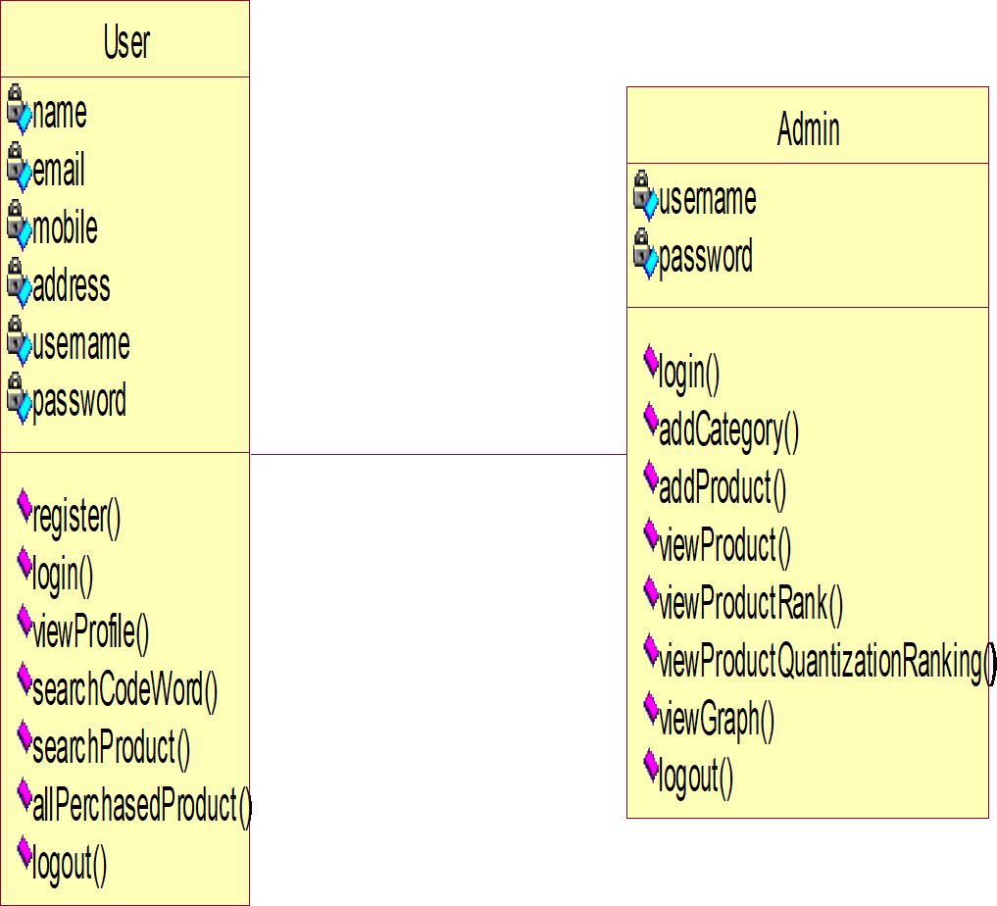

Fig:4.4ClassDiagram

SEQUENCEDIAGRAM
A sequence diagram in Unified Modeling Language (UML) is a kind of interaction diagram that shows how processes operate with one another and in what order. It is a construct of a Message Sequence Chart. Sequence diagrams are sometimes called event diagrams, event scenarios, and timing diagrams.

user
admin
database
register
login
login
addCategory
addProduct
viewAllProductRank
viewProductQuantizationInRank
viewGraph
myprofile
searchCordWord

searchProfile
allPurchasedProducts
logout
logout

Fig:4.5Sequence Diagram

INPUT&OUTPUT DESIGNS
    - INPUTDESIGN
Input design is part of overall system design that requires special attention designing input data is to make the data entered easy and free from errors. The input forms are designed using the controls available in .NETframework.Validation is made for each and every data that is entered. Help information is provided for the users during when the customer feels difficult.
Input design is the process of converting the user originated inputs to a computer- based format.Asystem user interacting through a workstation must be able to tell the system whether to accept the input to produce reports. The collection of input data is considered to be most expensive part of the system design. Since the input has to be planned in such a manner so as to get relevant information, extreme care is taken to obtain pertinent information.
This project first will entered to the input of allocation forms it will be created on student details form and subject entry form, time table form .it will helps to calculate subject wise attendance system. Next one if u wants any verification on your data’s also available in details show forms. Attendance to entered single subject wise or all subject wise attendance system available in this project

OUTPUTDESIGN
Output design this application “Student Attendance management system” generally refers to the results and information that are generated by the system for many end- users;outputisthemain reason fordevelopingthesystemandthebasison whichthey evaluate the usefulness of the application.
The output is designed in such a way that it is attractive, convenient and informative. Forms are designed with various features, which make the console output more pleasing.
Astheoutputsarethemostimportantsourcesofinformationtotheusers,better design should improve the system’s relationships with us and also will help in Decision making.
Form design elaborates the way output is presented and the layout available for capturing information.

One of the most important factors of the system is the output it produces. This system refers to the results and information generated. Basically, the output from a computer system is used to communicate the result of processing to the user.
Attendance management system to show the report subject wise attendance maintaining by staffs. Taken as a whole report obtain on a administrator privileges only. these forms will show weekly report and consolidate report generated date, batch, and class wise to our end user. we want to change our report to convert Excel format if you want change any modification.

CHAPTER5 SYSTEMIMPLEMENTATION

SYSTEMIMPLEMENTATION

MODULES
- User
- Admin

MODULAR DESCRIPTION

User
In this application the user should register with the application. then only the user can able to login into the homepage.
After he gets the access into the home page, he can do the following activities such as view profile, search code word, search products, all purchased products.
Thesearetheoperationwill goingto doby the user.

Admin
Admin also one of the module in the project, and the admin can perform the mainrole in this project.
Here the admin can directly login into the application, here the admin can add the category, add product, view all added products, view product count, view Product quantization ranking, view graph. These are the operations will done by the admin.

SOFTWAREENVIRONMENT
Machine learning is a discipline that deals with programming the systems so as to make them automatically learn and improve with experience. Here, learning implies recognizing and understanding the input data and taking informed decisions based on the supplied data. It is very difficult to consider all the decisions based on all possible inputs. To solve this problem, algorithms are developed that build knowledge from a specific data and past experience by applying the principles of statistical science, probability, logic, mathematical optimization, reinforcement learning, and control theory.

- .2 Steps Involved in Machine Learning:

A machine learning project involves the following step
  - Defining a Problem
  - Preparing Data
  - Evaluating Algorithms
  - Improving Results
  - Presenting Results

Machine Learning (ML) is an automated learning with little or no human intervention. It involves programming computers so that they learn from the available inputs. The main purpose of machine learning is to explore and construct algorithms that can learn from the previous data and make predictions on new input data.The input to a learning algorithm is training data, representing experience, and the output is any expertise, which usually takes the form of another algorithm that can perform a task. The input data to a machine learning system can be numerical, textual, audio, visual, or multimedia.

  - Machine Learning vs. Traditional Programming:

Traditional programming differs significantly from machine learning. In traditional programming, programmers code all the rules in consultation with an expert in the industry for which software is being developed. Each rule is based on a logical foundation; the machine will execute an output following the logical statement. When the system grows complex, more rules need to be written. It can quickly become sustainable to maintain.
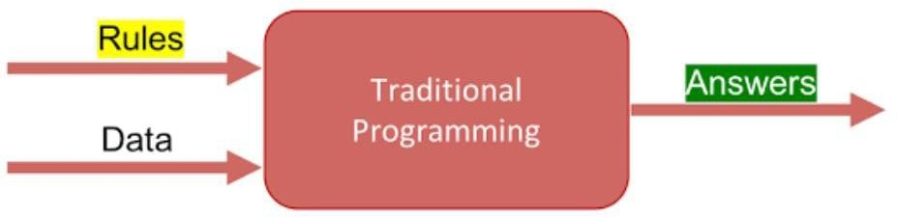

Fig 5.1: Traditional Programming
Machine learning is supposed to overcome this issue. The machine learns how the input and output data are correlated and it writes a rule. The programmers do not need to write new rules each time there is new data. The algorithms adapt in response to new data and experiences to improve efficacy over time.

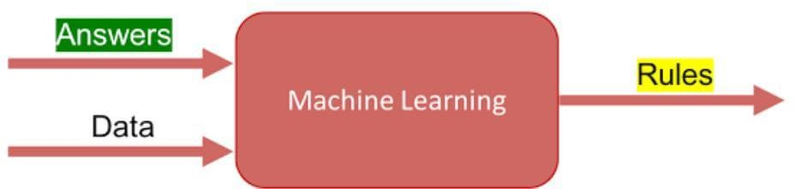

  - : Machine Learning

  - How does Machine learning work?

Machine learning is the brain where all the learning takes place. The way the machine learns is similar to the human being. Humans learn from experience. The more we know, the more easily we can predict. By analogy, when we face an unknown situation, the likelihood of success is lower than the known situation. Machines are trained the same. To make an accurate prediction, the machine sees an example. When we give the machine a similar example, it can figure out the outcome. However, like a human, if it’s feed a previously unseen example, the machine has difficulties to predict.

  - Machine learning Algorithms and where they are used?

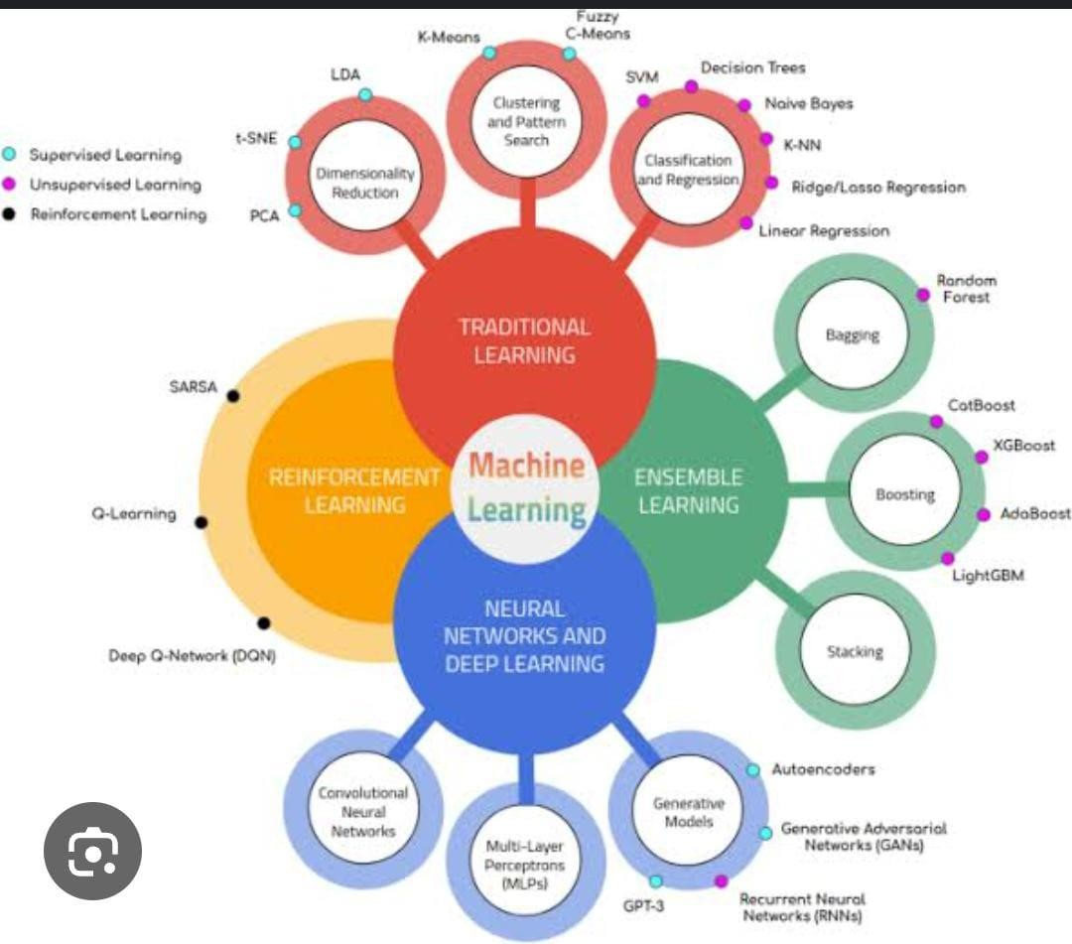

Fig 5.3: Machine Learning Algorithms

  - Types of Machine Learning:
There are four categories of machine learning algorithms as shown below

- Supervised learning algorithm
- Unsupervised learning algorithm
- Semi-supervised learning algorithm
- Reinforcement learning algorithm

    - Supervised Learning:

Supervised learning is commonly used in real world applications, such as face and speech recognition, products or movie recommendations, and sales forecasting.
Supervised learning can be further classified into two types - Regression and Classification. Regression trains on and predicts a continuous-valued response, for example predicting real estate prices. Classification attempts to find the appropriate class label, such as analyzing positive/negative sentiment, male and female persons, benign and malignant tumors, secure and unsecure loans etc. In supervised learning, learning data comes with description, labels, targets or desired outputs and the objective is to find a general rule that maps inputs to outputs. This kind of learning data is called labeled data. The learned rule is then used to label new data with unknown outputs. Supervised learning involves building a machine learning model that is based on labeled samples.

    - Unsupervised Learning:

Unsupervised learning is used to detect anomalies, outliers, such as fraud or defective equipment, or to group customers with similar behaviors for a sales campaign. It is the opposite of supervised learning. When learning data contains only some indications without any description or labels, it is up to the coder or to the algorithm to find the structure of the underlying data, to discover hidden patterns, or to determine how to describe the data. We may not exactly know what the criteria of classification would be. So, an unsupervised learning algorithm tries to classify the given dataset into a certain number of groups in an optimum way.

    - Semi-supervised Learning:

If some learning samples are labeled, but some other are not labeled, then it is semi-supervised learning. It makes use of a large amount of unlabeled data for training and a small amount of labeled data for testing. Semi-supervised learning is applied in cases where it is expensive to acquire a fully labeled dataset while more practical to label a small subset.

    - Reinforcement Learning:

Here learning data gives feedback so that the system adjusts to dynamic conditions in order to achieve a certain objective. The system evaluates its performance based on the feedback responses and reacts accordingly.

  - Challenges and Limitations of Machine learning:
The primary challenge of machine learning is the lack of data or the diversity in the dataset. A machine cannot learn if there is no data available. Besides, a dataset with a lack of diversity gives the machine a hard time. A machine needs to have heterogeneity to learn meaningful insight. It is rare that an algorithm can extract information when there are no or few variations. It is recommended to have at least 20 observations per group to help the machine learn. This constraint leads to poor evaluation and prediction.

  - Application of Machine learning :

- Augmentation:

Machine learning, which assists humans with their day-to-day tasks, personally or commercially without having complete control of the output. Such machine learning is used in different ways such as Virtual Assistant, Data analysis, software solutions.

- Automation:

Machine learning, which works entirely autonomously in any field without the need for any human intervention. For example, robots performing the essential process steps in manufacturing plants.

- Finance Industry:

Machine learning is growing in popularity in the finance industry. Banks are mainly using ML to find patterns inside the data but also to prevent fraud.
- Government organization

The government makes use of ML to manage public safety and utilities.Take the example of China with the massive face recognition.
- Marketing

Broad use of AI is done in marketing thanks to abundant access to data. Before the age of mass data, researchers develop advanced mathematical tools like Bayesian analysis to estimate the value of a customer. With the boom of data, marketing department relies on AI to optimize the customer relationship and marketing campaign.
  - Why is Machine Learning important?
Machine learning is the best tool so far to analyze, understand and identify a pattern in the data. One of the main ideas behind machine learning is that the computer can be trained to automate tasks that would be exhaustive or impossible for a human being. The clear breach from the traditional analysis is that machine learning can take decisions with minimal human intervention.

  - Python:
Python is a general-purpose interpreted, interactive, object-oriented, and high-level programming language. An interpreted language, Python has a design philosophy that emphasizes code readability (notably using whitespace indentation to delimit code blocks rather than curly brackets or keywords), and a syntax that allows programmers to express concepts in fewer lines of code than might be used in languages such as C++or Java. It provides constructs that enable clear programming on both small and large scales. Python interpreters are available for many operating systems. Python, the reference implementation of Python, is open source software and has a community-based development model, as do nearly all of its variant implementations. CPython is managed by the non-profit Python Software Foundation. Python features a dynamic type system and automatic memory management.
It supports multiple programming paradigms, including object oriented, imperative, and functional and has a large and comprehensive standard library.
  - python libraries for machine learning:

- NumPy:
NumPy is a library for the Python programming language, adding support for large, multi-dimensional arrays and matrices, along with a large collection of high-level mathematical functions to operate on these arrays. The core functionality of NumPy is its
"ndarray", for n-dimensional array, data structure. These arrays are strided views on memory. In contrast to Python's built-in list data structure, these arrays are homogeneously typed: all elements of a single array must be of the same type.
- Pandas:
Pandas is the most popular python library that is used for data analysis. It provides
highly optimized performance with back-end source code is purely written in C or Python.
We can analyze data in pandas with Series and Data Frames.

- Matplotlib:
Matplotlib is a python library used to create 2D graphs and plots by using python scripts. It has a module named pyplot which makes things easy for plotting by providing feature to control line styles, font properties, formatting axes etc. It supports a very wide variety of graphs and plots namely histogram, bar charts, power spectra, error charts etc. It is used along with NumPy to provide an environment that is an effective open source alternative for MatLab. It can also be used with graphics toolkits like PyQt and wxPython.
- Scikit-learn:
Scikit-learn is a machine learning library for Python. It features several regression, classification and clustering algorithms including SVMs, gradient boosting, k-means, random forests and DBSCAN. Scikit is written in Python (most of it) and some of its core algorithms are written in Cython for even better performance. Scikit-learn is used to build models and it is not recommended to use it for reading, manipulating and summarizing data as there are better frameworks available for the purpose. It is open source and released under BSD license.
- Seaborn:
Seaborn is an open source, BSD-licensed Python library providing high level API for visualizing the data using Python programming language. Data can be visualized by representing it as plots which is easy to understand, explore and grasp. Such data helps in drawing the attention of key elements. To analyze a set of data using Python, we make use of Matplotlib, a widely implemented 2D plotting library. Likewise, Seaborn is a visualization library in Python. It is built on top of Matplotlib.

  - Uses of Python:

- Applications:
Python can be used to develop different applications like web applications, graphic user interface based applications, software development application, scientific and numeric applications, network programming, Games and 3D applications and other business applications. It makes an interactive interface and easy development of applications.
- Multiple Programming paradigms:
Python is also used because of its providing continuous support to several programming paradigms. As it supports object-oriented programming and structured programming. Python has features, which also support various concepts of functional

programming language. It is used for dynamic type system and automatic memory management. Python language features and programming paradigms allow you for developing the small as well as large applications. It can be used for complex software applications.
- Robust Standard Library:
Python has a large and robust standard library to use for developing the applications. It also makes the developers use Python over other languages. The standard library helps in using the different range of modules available for Python. As this module helps you in adding the functionality without writing any more code. To get the information about various modules, documentation on python standard library can be referred. While developing any web application, implementing web services, performing string operations and other usages like interface protocol, the standard library documentation helps.
- Compatible with Major Platforms and Systems:
Python is mainly compatible with major platforms and systems because of which it is used mainly for developing applications. With help of python interpreters, python code can be run on specific platforms and tools as it supports many operating systems. As python is an interpreted high-level programming language and it allows you to run the code on multiple platforms.
The new and modified code can be executed without recompiling and its impact can be monitored or checked. It means it’s not required to recompile the code after every change. This feature helps in saving the development time of the developers. 5Access of Database:
Uses of Python also helps in accessing the database easily. Python helps in customizing the interfaces of different databases like MySQL, Oracle, Microsoft SQL Server, PostgreSQL, and other databases. It has an object database like Durus and ZODB. It is used for standard database API and freely available for download.
- Code Readability:
Python code is easy to read and maintained. It is easily reusable as well wherever it is required. Python’s having simple syntax, which allows the different concepts to develop without writing any additional code. The code should be of good quality and easy to maintain the source code and simplify the maintenance, which is required to develop the software application. It also emphasizes code readability, which is the great feature, unlike other programming languages. It helps in building custom applications and clean code helps in maintaining and updating the software applications without putting extra effort on the same code.

- Simplify Complex Software Development:
Applications of Python is used to simplifying the complex software development process as it is a general-purpose programming language. It is used for developing the complex application like scientific and numeric application, and for both desktop and web applications. Python has features like analyzing data and visualization, which helps in creating custom solutions without putting extra effort and time. It helps you to visualize and present data in an effective way.
- Many Open Source Frameworks and Tools:
Python is open source and easily available. This also helps in costing the software development significantly. There are many open source applications of python frameworks, libraries, and development tools for developing the application without putting extra cost.
Python frameworks simplify and make the process faster for web application development and the frameworks are Django, Flask, pyramid etc. Python GUI frameworks are available for developing the GUI based application.
- Adopt Test Driven Development:
Python makes coding easier as well as testing with help of adopting Test Driven Development approach. The test cases can be easily written before any code development. Whenever the code development started, the written test cases can start testing the code simultaneously and provides the result. These can also be used for checking or testing the pre-requirements based on the source code.
- Other applications for which python is used:
There are other applications for which python is used that are Robotics, web scraping, scripting, artificial intelligence, data analysis, machine learning, face detection, color detection, 3D CAD applications, console-based applications, audio-based applications, video-based applications, enterprise applications, and applications for Images etc. These are some major applications used.
  - Neural network:
Is a machine learning algorithm, which is built on the principle of the organization and functioning of biological neural networks. This concept arose in an attempt to simulate the processes occurring in the brain by Warren McCulloch and Walter Pitts in 1943.
Neural networks consist of individual units called neurons. Neurons are located in a series of groups — layers (see figure allow).

Neurons in each layer are connected to neurons of the next layer. Data comes from
the input layer to the output layer along these compounds.
Each individual node performs a simple mathematical calculation. Тhen it transmits its data to all the nodes it is connected to.
The last wave of neural networks came in connection with the increase in computing power and the accumulation of experience.
That brought Deep learning, where technological structures of neural networks have become more complex and able to solve a wide range of tasks that could not be effectively solved before. Image classification is a prominent.

SOURCECODE

from tkinter import * import tkinter as tk
from PIL import Image ,ImageTk from tkinter.ttk import *
from pymsgbox import *

root=tk.Tk()

root.title("fruit and vegetable disease detection ")
w,h = root.winfo_screenwidth(),root.winfo_screenheight()

bg = Image.open("56.jpg") bg.resize((1300,600),Image.ANTIALIAS) print(w,h)
bg_img = ImageTk.PhotoImage(bg) bg_lbl = tk.Label(root,image=bg_img) bg_lbl.place(x=0,y=90)
#, relwidth=1, relheight=1)

w = tk.Label(root, text=" Fruit And Vegetable Disease Detection system ",width=40,background="#212F3D",foreground="white",height=2,font=("Times new roman",19,"bold"))
w.place(x=0,y=15)

w,h = root.winfo_screenwidth(),root.winfo_screenheight() root.geometry("%dx%d+0+0"%(w,h)) root.configure(background="#212F3D")

from tkinter import messagebox as ms

root.configure(background="#212F3D")
from tkinter import messagebox as ms
def Login ():
from subprocess import call call(["python","login.py"])
def Register():
from subprocess import call call(["python","registration.py"])

wlcm=tk.Label(root,text="......Welcome to Fruit And Vegetable Disease Detection system
. ",width=95,height=3,background="#212F3D",foreground="white",font=("Times new
roman",22,"bold")) wlcm.place(x=0,y=600)

d2=tk.Button(root,text="Login",command=Login,width=9,height=2,bd=0,background="#212 F3D",foreground="white",font=("times new roman",14,"bold"))
d2.place(x=1000,y=18)

d3=tk.Button(root,text="Register",command=Register,width=9,height=2,bd=0,background=" #212F3D",foreground="white",font=("times new roman",14,"bold"))
d3.place(x=1100,y=18)

root.mainloop()

CHAPTER6 SYSTEMTESTING

SYSTEMTEST
The purpose of testing is to discovererrors.Testing is the process of trying to discover every conceivable fault or weakness in a work product. It provides a way to check the functionality of components, sub-assemblies, assemblies and/or a finished product Itis the process of exercising software with the intent of ensuring that the Software system meets its requirements and user expectations and does not fail in an unacceptable manner. There are various types of test. Each test type addresses a specific testing requirement.

TYPESOF TESTS
    - UNITTESTING
Unit testing involves the design of test cases that validate that the internal program logic is functioning properly, and that program inputs produce valid outputs. All decision branches and internal code flow should be validated. It is the testing of individual software units of the application .it is done after the completion of an individual unit before integration.This is a structural testing, that relies on knowledge of its construction and is invasive. Unit tests perform basic tests at component level and test a specific business process, application, and/or system configuration. Unit tests ensure that each unique path of a business process performs accurately to the documented specifications and contains clearly defined inputs and expected results.

INTEGRATIONTESTING
Integration tests are designed to test integrated software components to determine if they actually run as oneprogram.Testing is event driven and is more concerned with the basic outcome of screens or fields. Integration tests demonstrate that although the components were individually satisfaction, as shown by successfully unit testing, the combination of components is correct and consistent. Integration testing isspecifically aimed atexposing the problems that arise from the combination of components.

FUNCTIONALTEST
Functionaltestsprovidesystematicdemonstrationsthatfunctionstestedareavailable as specified by the business and technical requirements, system documentation, and user manuals.
Functionaltestingiscenteredonthe followingitems:

Valid Input :identifiedclassesofvalidinputmustbeaccepted. Invalid Input :identifiedclassesofinvalidinput mustberejected. Functions : identified functions must be exercised.
Output :identifiedclassesofapplicationoutputsmustbeexercised. Systems/Procedures: interfacing systems or procedures must be invoked.
Organization and preparation of functional tests is focused on requirements, key functions, or special test cases. In addition, systematic coverage pertaining to identify Business process flows; data fields, predefined processes, and successive processes must be considered for testing. Before functional testing is complete, additional tests are identified and the effective value of current tests is determined.

SYSTEMTEST
System testing ensures that the entire integrated software system meets requirements. Ittestsaconfigurationto ensureknownandpredictableresults.An exampleofsystem testingistheconfiguration-orientedsystemintegrationtest.Systemtestingisbasedon process descriptions and flows, emphasizing pre-driven process links and integration points.

WHITE BOXTESTING
WhiteBoxTesting isatesting inwhich in which thesoftwaretesterhas knowledgeof the inner workings, structure and language of the software, or at least its purpose. It is purpose. It is used to test areas that cannot be reached from a black box level.

BLACKBOX TESTING
Black Box Testing is testing the software without any knowledge of the inner workings, structure or language of the module being tested. Black box tests, as most other kinds of tests, must be written from a definitive source document, such as specification or requirements document, such as specification or requirements document. It is atesting in which thesoftwareundertest is treated,as ablack box you cannot “see” into it. The test provides inputs and responds to outputs without considering how the software works.

UNITTESTING
Unit testing is usually conducted as part of a combined code and unit test phase of the software lifecycle, although it is not uncommon for coding and unit testing to be conducted as two distinct phases.

TESTSTRATEGYANDAPPROACH
Fieldtestingwillbeperformedmanuallyandfunctionaltestswillbewrittenin detail.

Testobjectives
- Allfieldentriesmustwork properly.
- Pagesmustbeactivatedfromtheidentifiedlink.
- Theentry screen,messages andresponses mustnot bedelayed.

Featurestobe tested
- Verifythattheentriesare ofthecorrectformat.
- Noduplicateentries shouldbe allowed.
- Alllinksshould taketheuser tothecorrect page.

INTEGRATIONTESTING
Software integration testing is the incremental integration testing of two or more integrated software components on a single platform to produce failures caused by interface defects. The task of the integration test is to check that components or software applications, e.g. components in a software system or – one step up – software applications at the company level – interact without error.
Test Results: All the test cases mentioned above passed successfully. No defects encountered.

ACCEPTANCE TESTING
User Acceptance Testing is a critical phase of any project and requires significant participation by the end user. It also ensures that the system meets the functional requirements.
Test Results: All the test cases mentioned above passed successfully. No defects encountered.

CHAPTER7 SCREENSHOTS

SCREENSHOTS

SCREENS

Description:The abovescreenshows thethreemodulesi.e., Home, User,E-seller.

SCREENS

Description:Intheabovescreenloginpagewillappearandalsoregisternew persons.

SCREENS

Description:Thisscreenisusedtoregisterapersonandalltheirdetailswillbe entered.

SCREENS

Description:Thisslidewillappearaftertheregistrationofaperson.

SCREENS

Description:AftertheregistrationprocesslogintotheE-sellerpage.

SCREENS

Description:Theabove screen showstheloginis successful.

SCREENS

Description:Userregistereddetailswillbeappearedintheabove screen.

SCREENS

Description:Aftertheuserregistrationtheywillbeauthorizedine-sellerlogin.

SCREENS

Description:Theabove screendisplaysthesidebarmenuintheEsellermainpage.

SCREENS

Description: Inthesidebarmenutheview andAuthorizeUsers willdisplay.

SCREENS

Description:ThisslideshowsthedetailsofUsersri’sprofile.

SCREENS

Description:Thisslidewillappearinthewelcometo E-sellerloginpagetosearchfor friends.

SCREENS

Description:Inthisslideifthesearchedfriendwillbetherethenitappearasresult found.

SCREENS

Description:Thisslideshowsthefulldetailsofthepersonwhomyouwanttobe friends.

SCREENS

Description:TheFriendrequestwillbesendtothepersonSuccessfully.

SCREENS

Description:Thisslideshowsthefriendrequests oftheuserhari.

SCREENS

Description:This slideshows thefriends oftheuser sri.

SCREENS

Description:Theabovescreenshows theallmenu inthewelcometoEseller page.

SCREENS

Description: This screen will appear in the Add and View products which are appear in the E-seller login.

SCREENS

Description:Ifthesearchedproduct willbein thatpagethenitappear inthisscreen.

SCREENS

Description: Iftheresultfoundthenthatproductdetailswillappearinthisscreen.

SCREENS

Description: The details of the product will be appear and also we can see reviews of that product.

CHAPTER8 CONCLUSION

CONCLUSION
In conclusion, the Fruits and Vegetables Disease Detection Using CNN project provides an efficient, accurate, and automated way to identify plant diseases. By using deep learning, the system can analyze images of affected fruits and vegetables and classify diseases with high precision. This helps farmers take quick action, preventing crop loss and improving agricultural productivity.Compared to traditional manual inspection, the proposed system is faster, cost-effective, and reduces human error. It can be easily deployed as a mobile or web application, making it accessible to farmers and agricultural experts. Although challenges like dataset quality and real-world conditions exist, continuous improvements in AI and data collection can enhance the system's performance.Overall, this project has the potential to revolutionize disease detection in agriculture, contributing to healthier crops and better food production.

REFERENCES

- Mohanty, S. P., Hughes, D. P., & Salathé, M. (2016). Using deep learning for image- based plant disease detection. Frontiers in Plant Science, 7, 1419.
- Too, E. C., Yujian, L., Njuki, S., & Yingchun, L. (2019). A comparative study of fine- tuning deep learning models for plant disease identification. Computers and Electronics in Agriculture, 161, 272-279.
- Fuentes, A., Yoon, S., Kim, S. C., & Park, D. S. (2017). A robust deep-learning-based detector for real-time tomato plant diseases and pests detection. Sensors, 17(9), 2022.
- Zhang, S., Wang, X., You, Z., & Zhang, L. (2018). Leaf image-based cucumber disease recognition using deep learning models. Computers and Electronics in Agriculture, 154, 135-141.
- Brahimi, M., Boukhalfa, K., & Moussaoui, A. (2017). Deep learning for tomato diseases: Classification and symptoms visualization. Applied Artificial Intelligence, 31(4), 299-315.
- Sladojevic, S., Arsenovic, M., Anderla, A., Culibrk, D., & Stefanovic, D. (2016). Deep neural networks based recognition of plant diseases by leaf image classification. Computational Intelligence and Neuroscience, 2016, 3289801.
- Amara, J., Bouaziz, B., & Algergawy, A. (2017). A deep learning-based approach for banana leaf diseases classification. Lecture Notes in Informatics, 281, 79-88.
- Ramcharan, A., Baranowski, K., McCloskey, P., Ahmed, B., Legg, J., & Hughes, D. (2017). Deep learning for image-based cassava disease detection. Frontiers in Plant Science, 8, 1852.
- Abbas, S., Iftikhar, M., Saleem, B. A., & Wahid, A. (2019). Identification of citrus plant diseases using deep learning models. International Journal of Agricultural Research, 10(2), 93-102.
- Rehman, A., Maqsood, M., Saba, T., & Mehmood, Z. (2018). Deep learning-based plant disease detection for agricultural crops: A review. Journal of Agricultural Science and Technology, 20(1), 23-36.
- Hasan, M. M., Alom, M. Z., Taha, T. M., & Yakopcic, C. (2019). Plant disease detection using deep convolutional neural networks. Neural Computing and Applications, 31(10), 6071-6081.
- Brahim, A., Alimi, A., & Chihi, I. (2020). Deep learning approach for plant diseases detection. Pattern Recognition and Image Analysis, 30(2), 315-326.
- Goodfellow, I., Bengio, Y., & Courville, A. (2016). Deep Learning. MIT Press.
- Chollet, F. (2017). Deep Learning with Python. Manning Publications
- Géron, A. (2019). Hands-On Machine Learning with Scikit-Learn, Keras, and TensorFlow (2nd ed.). O'Reilly Media.
- Andrew Ng. Deep Learning Specialization. Coursera (Online Course).
- Bishop, C. M. (2006). Pattern Recognition and Machine Learning. Springer.
- Aggarwal, C. C. (2018). Neural Networks and Deep Learning: A Textbook. Springer.

- Raschka, S., & Mirjalili, V. (2019). Python Machine Learning: Machine Learning and Deep Learning with Python, Scikit-Learn, and TensorFlow 2, 3rd Edition. Packt Publishing.

- Kamal, K. C., & Lee, M. (2020). Hybrid deep learning models for plant disease detection.
- Wu, D., Yang, C., & Chen, H. (2020). Development of deep learning-based plant disease recognition system.
- Pantazi, X. E., Moshou, D., & Alexandridis, T. (2019). Spectral and CNN-based disease detection in crops.
- Lu, J., Hu, J., & Zhao, G. (2021). Lightweight CNN models for mobile-based plant disease detection.
- Acharya, S., & Sahoo, S. (2022). Leaf lesion segmentation for disease classification using deep learning.
- Patel, V., & Patel, P. (2021). Transfer learning for robust fruit disease detection in complex backgrounds.
- Yang, X., & Wu, C. (2021). Optimization of CNN architectures for multi-class plant disease detection.
- Hu, X., & Li, Y. (2022). Real-time plant disease detection using CNN on edge devices.
- Bhagat, A., & Singh, M. (2023). Comparative study of CNN-based architectures for plant disease classification.

CHAPTER 10 FUTUREENHANCEMENT

FUTUREENHANCMENT

Future enhancements for fruits and vegetables disease detection using CNN can focus on improving accuracy, efficiency, and real-time usability. Implementing lightweight models optimized for mobile devices can allow farmers to detect diseases instantly using smartphones. Integrating the system with IoT devices and drones can enable large-scale monitoring of crops. Models can be enhanced to detect multiple diseases at once and predict the severity of infections. Explainable AI techniques can be used to highlight affected areas and provide treatment recommendations. Continuous learning models can be developed to improve accuracy over time without needing frequent retraining. Training datasets can be expanded to include images from different weather conditions and environments for better adaptability. Automated treatment recommendations can be added based on disease detection results. Advanced techniques like 3D image analysis and hyperspectral imaging can improve detection precision. Blockchain technology can be used to store disease data securely and track outbreaks. Combining CNN with other AI techniques, such as transformers and multimodal learning, can further enhance performance and reliability in agricultural disease detection.

FRUITS AND VEGETABLES DISEASE DETECTION USING CNN

ONLINEPRODUCTQUANTIZATION
¹K.SRILAKSHMIAPURUPA,²K.JASWANTH
¹M.TECHDEPTOFCSE,KAKINADAINSTITUTEOFTECHNOLOGICALSCIENCES,RAMACHANDRAPURAM,ANDHR
APRADESH,INDIA,533255
²ASSISTANTPROFESSOR,KAKINADAINSTITUTEOFTECHNOLOGICALSCIENCES,RAMACHANDRAPURAM,AND
HRAPRADESH,INDIA,533255

ABSTARCT
Approximate nearest neighbor (ANN) search has achieved great success in many tasks.However, existing popular methods for ANN search, such as hashing and quantization methods, are designed for static databases only. They cannot handle well the database with data distribution evolving dynamically, due to the high computational effort for retraining the model based on the new database. In this paper, we address the problem by developing an online product quantization (online PQ) model and incrementally updating the quantization codebook that accommodates to the incoming streaming data. Moreover, to further alleviate the issue of large scale computation for the online PQ update, we design two budget constraints for themodel to updatepartialPQcodebook instead ofall. Wederivealossboundwhich guarantees the performance of our online PQ model. Furthermore, we develop an online PQ model over a slidingwindowwithbothdatainsertionanddeletionsupported,toreflectthereal-timebehaviour of the data. The experiments demonstrate that our online PQ model is both time-efficient and effective for ANN search in dynamic large scale databases compared with baseline methods and the idea of partial PQ codebook update further reduces the update cost.

INTRODUCTION
APPROXIMATE nearest neighbour (ANN) search in a static database has achieved great success in supporting many tasks, such as information retrieval, classificationandobjectdetection.However, due to the massive amount of datageneration at an unprecedented rate daily in the era of big data, databases are dynamically growing with data distribution evolving over time, and existing ANNsearch methods would achieveunsatisfactory performance without newdata incorporated in their models. In addition,itisimpracticalforthesemethods
to retrain the model from scratch for the continuously changing database due to the large scale computational time and memory. Therefore, it is increasingly important to handle ANN search in a dynamic database environment.ANN search in a dynamic database has a widespread applications inthe real world. For example, a large number of news articles are generated and updated on hourly/daily basis, so a news searching system [1] requires to support news topic tracking and retrieval in a frequently changing news database. For objectdetection in video surveillance [2],videodataiscontinuouslyrecorded,sothatth e

distances between/among similar or dissimilar objects are continuouslychanging. For image retrieval in dynamic databases [3], relevant images are retrieved from a constantly changing imagecollection, and the retrieved images could therefore be different over time given the same image query. In such an environment, real-time query needs to be answered based on all the data collected to the database so far. In recent years, there has been an increasing concern over the computational cost and memory requirement dealing with continuously growing large scale databases, and therefore there are manyonline learning algorithm works [4], [5],[6] proposed to update the model each time streaming data coming in. Therefore, we consider the following problem. Given a dynamic database environment, develop an online learning model accommodating the new streaming data with low computational cost for ANN search.
Recently, several studies on online hashing[7],[8],[9],[10],[11],[12],[13]
show that hashing based ANN approaches can be adapted to the dynamic database environment by updating hash functions accommodating new streaming data andthen updating the hash codes of the exiting stored data via the new hash functions. Searching is performed in the Hamming space which is efficient and has low computational cost. However, an important problemthattheseworkshavenotaddressed is the computation of the hash code maintenance. To handle the streaming fashionofthedata,thehashfunctionsare
required to be frequently updated, whichwill result in constant hash code recomputation of all the existing data in the reference database. This will inevitablyincuranincreasingamountofupdatet imeas the data volume increases. In addition, these online hashing approaches require the system to keep the old data so that the new hash code of the old data can be updated eachtime,leadingtoinefficiencyinmemory and computational load. Therefore, computational complexity and storage cost arestill ourmajorconcerns in developing an online indexing model.
Product quantization (PQ) [14] is an effective and successful alternative solution for ANN search. PQ partitions the original space into a Cartesian product of low dimensional subspaces and quantizes each subspace into a number of sub-codewords.In this way, PQ is able to produce a large number of code words with low storage cost and perform ANN search with inexpensive computation. Moreover, it preserves the quantization error and can achieve satisfactory recall performance. Most importantly, unlike hashing-based methods representing each data instance by a hash code, which depends on a set of hash functions, quantization based methods represent each data instance by an index, which associates with a codeword that is in thesamevectorspacewiththedatainstance.
However,PQis abatchmodemethodwhich is not designed for the problem of accommodatingstreamingdatainthemodel.
Therefore, to address the problem of handlingstreamingdata for ANN searchand

tackle the challenge of hash code recomputation, we develop an online PQ approach, which updates the code words by streaming data without the need to update the indices of the existing data in the reference database, to further alleviate the issue of large scale update computational costs

EXISTINGSYSTEM
Existinghashingmethods are groupedin data-independent hashing and data- dependent hashing. One of the most representative work for data-independent hashingis LocalitySensitiveHashing(LSH) [20], where its hashing functions are randomlygenerated. LSHhasthetheoretical performance guarantee that similar data instances will be mapped to similar hash codes with a certain probability. Since data- independent hashing methods are independent from the input data,theycanbe easily adopted in an online fashion.
Data-dependent hashing, on the other hand, learns the hash functions from the given data, which can achieve better performance than data independent hashing methods. Its representative works are Spectral Hashing (SH) [19], which uses spectral method to encode similarity graphof the input into hash functions, IsoH [18] which finds a rotation matrix for equal variance in the projected dimensions and ITQ [17] which learns an orthogonalrotation matrix for minimizing the quantization error of data items to their hash codes.
To handle nearest neighbor search in a dynamicdatabase,onlinehashingmethods
have attracted a great attention in recent years. They allow their models to accommodate to the new data coming sequentially, without retraining all stored data points. Specifically, Online Hashing, AdaptHash and Online Supervised Hashing are online supervised hashing methods, requiringlabel information,whichmightnot be commonly available in many real-world applications. Stream Spectral BinaryCoding (SSBC) [9] and Online Sketching Hashing (OSH) are the only two existing online unsupervised hashing methods which do not require labels, where both of them arematrix sketch-based methods to learn to represent the data seen so far by a small sketch.
However,allthe onlinehashingmethods suffer from the existing data storage and the high computational cost of hash code maintenance on the existing data. Each time new data comes, they update their hash functions accommodating to the new data and then update the hash codes of all stored data according to the new hash functions, which could be very time-consuming for a large scale database.

Disadvantages
There is no Online Hashing Methods for Online Product Quantization. There is no ANN search instead kNN Search Methods.

PROPOSED SYSTEM
In the Proposed system, the system implemented Product quantization (PQ) which is an effective and successful alternative solution for ANN search. PQ partitions the original space into a Cartesian productoflowdimensionalsubspacesand

quantizeseachsubspaceintoanumberof sub- code words.Inthisway,PQ isable to produce a large number of code words with lowstoragecostandperformANNsearch with inexpensive computation. Moreover, it preservesthequantizationerrorandcan achieve satisfactory recall performance.
Most importantly, unlike hashing-based methods representing eachdata instance bya hash code, which depends on a set of hash functions, quantization based methods representeachdatainstancebyanindex, which associates with a codeword that is in thesamevectorspacewiththedatainstance.
However,PQisabatchmodemethod whichisnotdesignedfortheproblemof accommodatingstreamingdatainthemodel. Therefore, to address the problem of handlingstreamingdataforANNsearchand tackle the challenge of hash code recomputation, the system develops an online PQ approach, which updates the code words bystreaming data without the need to update the indices of the existing data in the referencedatabase,tofurtheralleviatethe issueoflargescaleupdatecomputational
cost.

Advantages
The Proposed product quantizer in PQ, on the other hand, updates the codeZords inthe codebook, but it does not change the index of the updated code words of eachdata point in the reference database. To handle nearest neighbor search in a dynamic database, online hashing methods have attracted a great attention in the proposed system.

IMPLEMENTATION

1. 1AdminServer
In this module, the Admin has to login by using valid user name and password. After login successful he can perform some operations such as List all users and authorize, Register with News channel name and login, Add News Categories, Set news quantization date, Select category and add news, List all news post and give option to update and delete, List all news post by quantization, List All News Posts by clusters based on news cat, List All Users News transactions by keyword, View online product quantization by chart, View all news post rank in chart.

5.2User
In this module, there are n numbers of users are present. User should register before performing any operations. Once user registers, their details will be stored to the database.After registration successful, he has to login by using authorized user name andpassword.Once Loginissuccessfuluser canperformsomeoperationslikeView your profile, Search news by content keyword, select hash code to show all news titles, Show all your search transactions based on keyword and hash code.

VISCREENSHOTS

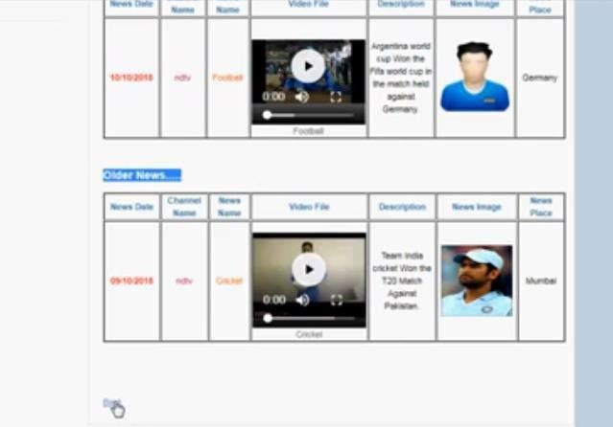
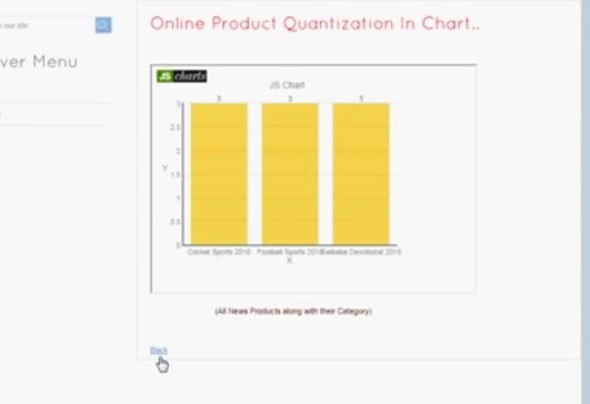
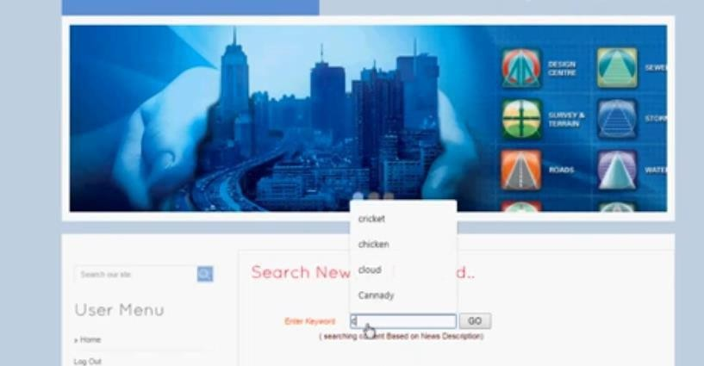

VICONCLUSION
In this paper, we have presented our online PQ method to accommodate streaming data. In addition, we employ two budgetconstraintstofacilitatepartial
codebook update to further alleviate the update time cost. A relative loss bound has been derived to guarantee the performanceof our model. In addition, we propose an online PQ over sliding window approach, to emphasize on the real-time data. Experimental results show that our methodis significantly faster in accommodating the streaming data, out performs the competing online hashing methods and unsupervised batch mode hashing method in terms of search accuracy and update time cost, and attains comparable search qualitywith batch mode PQ.

VII.REFERENCES
- A. Moffat, J. Zobel, and N. Sharman, “Text compression for Dynamic document databases,”TKDE,vol.9,no.2,pp.302– 313,1997.
- R. Popovici, A. Weiler, and M. Grossniklaus, “On-line clustering for real- time topic detection in social media streaming data,” in SNOW 2014 Data Challenge, 2014, pp. 57–63.
- A. Dong and B. Bhanu, “Concept learning and transplantation for dynamic image databases,” in ICME, 2003, pp. 765– 768.
- K. Crammer, O. Dekel, J. Keshet, S. Shalev-Shwartz, and Y. Singer,“Online passive-aggressive algorithms,” JMLR, vol. 7, pp. 551–585,2006.
- C. Li, W. Dong, Q. Liu, and X. Zhang, “Mores: online incremental multiple-output regression for data streams,” CoRR, vol.abs/1412.5732, 2014.
- L.Zhang,T.Yang,R.Jin,Y.Xiao,and Z.Zhou,“Onlinestochasticlinear

optimization under one-bit feedback,” in ICML, 2016, pp.392–401.
- L. Huang, Q. Yang, and W. Zheng, “Online hashing,” in IJCAI,2013, pp. 1422– 1428.
- “Onlinehashing,”NNLS,2017.
- M. Ghashami and A. Abdullah, “Binary coding in stream,” CoRR,vol. abs/1503.06271, 2015.
- C.Leng,J.Wu,J.Cheng,X.Bai,and
H. Lu, “Online sketchinghashing,” inCVPR, 2015, pp. 2503–2511.
- F. Cakir and S. Sclaroff, “Adaptive hashing for fast similarity search,” in ICCV, 2015, pp. 1044–1052.
- Q. Yang, L. Huang,W. Zheng, and Y. Ling, “Smart hashing update for fast response,” in IJCAI, 2013, pp. 1855–1861.
- F.Cakir,S.A.Bargal,andS.Sclaroff, “Onlinesupervisedhashing,”CVIU,2016.
- H. J´egou, M. Douze, and C. Schmid, “Product quantization fornearest neighbor search,”PAMI,vol.33,no.1,pp.117–128, 2011.
- M. Norouzi and D. J. Fleet, “Minimal loss hashing for compactbinary codes,” in ICML, 2011, pp. 353–360.
- W. Liu, J. Wang, R. Ji, Y. Jiang, and S. Chang,“Supervisedhashingwithkernels,”in CVPR, 2012, pp. 2074–2081.
- Y. Gong and S. Lazebnik, “Iterative quantization: A procrustean approach to learning binary codes,” in CVPR, 2011, pp. 817–824.
- W. Kong and W. Li, “Isotropic hashing,” in NIPS, 2012, pp. 1655–1663.
- Y. Weiss, A. Torralba, and R. Fergus, “Spectralhashing,”inNIPS,2008,pp.1753– 1760.
- A. Gionis, P. Indyk, and R. Motwani, “Similarity search in high dimensions via hashing,” in VLDB, 1999, pp. 518–529.
- A. Babenko and V. S. Lempitsky, “Additive quantization for extreme vector compression,”inCVPR,2014,pp. 931–938.

